Should Cellphones Be Banned From Vehicles?

By Elona Cubaj

I don't think cell phones should be banned from vehicles. If there was an emergency you would need your cellphone. For instance, if someone was in a car accident, you would need your phone to call 911.

If something happened at home and your family member tried to call you, you wouldn't be able to answer. If my family needed something, how would I be able to help if I didn’t know they needed me?

Sometimes, we need our cell phones to see directions. Let's say you're going to a new workplace or a new school to check it out. You probably need your phone to find the address. What if you found a lost pet? You would need your phone to call the owner, or if it was a lost animal you would have to call a shelter to take the animal in.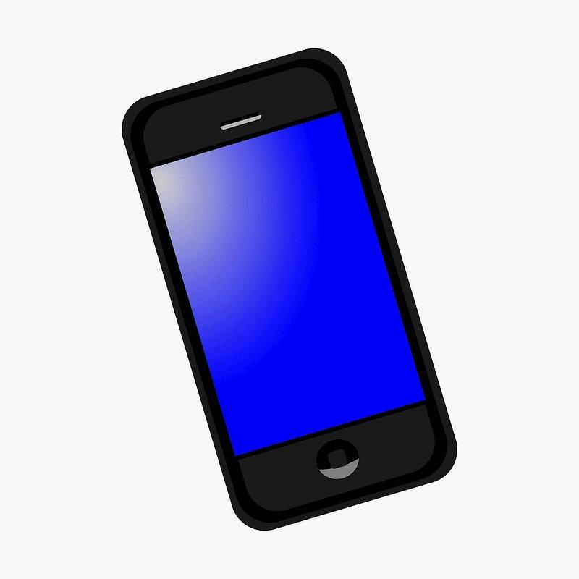

In conclusion, I believe cell phones should not be banned from use in vehicles because of how many things that could happen if you didn't have your phone with you. What do you think?